Digital Multilayer Perceptron

Computing Advanced Higher Project

Bradley Liam Milne

SCN: 110277571

Start Date: 10/10/2022
End Date: 27/03/2023
Project Description:

I intend on creating a program to convert images or photo-scans of documents to plain text to be used by the user or another program. This will be accomplished with the use of basic image processing and a text classifying neural network. The user will gain access to this software with the use of a html interface hosted by the program, in this the user may upload images for processing, receive results, and troubleshoot unreliable results using an analytical page showing all relevant information. The back-end software will be created using node.js and in the form of a npm package that can be utilised by either; the html interface, or by another program as an API. To meet all advanced higher requirements my project will include; A major of software development that includes arrays of records for holding the input data for each letter, insertion sort for sorting and selecting the most likely result, and a fully modular and object oriented program. And a minor in web development that will include; a multi-page website with a hierarchical design and a dynamic navigation bar, a forum for inputting a file of a photo or scan, and an output page where the user can acquire the results

Scope:

For the Software:
- Full design documentation (structure diagram, pseudocode for each each function, UML use case diagrams)
- Encompassing test plan (individual component tests, integrative tests, final and test)
- Finished software
- Testing results
- Evaluation

For the Web GUI:
- Web design documentation (wireframe design, UML use case diagrams)
- Testing of server side processing and on page scripting
- Finished GUI
- Testing results
- Evaluation

Boundaries:

- Accurate input test data, program will learn of this data if not reliable no reliable results will be acquired
- The input image must have clear sharp text of a serif or sans-serif typeface
- Text must be monochrome, and in portrait orientation

Functional requirements:

Software requirements:
- The software will be able to host the website and allow for the transfer of data between the web GUI and the back-end software
- The software will have to be able to take inputted training data and process it and store it as an array of records for later use
- The software will have to run the neural network training and run the trained network for certainties
- The software will have to be able to store results of training as an array of records and sort them by letter and certainty to send to the analytics page

html GUI requirements:
- The website will have a way to upload training data with an image and its correct result
- The website will include an editor for the neural network script so that the programmer can edit the way it works
- The website will include a live interaction page that will allow the programmer to test the network with test data on the fly
- The website will include an analytics page that allows the programmer to discover any issues with the trained network and resolve them

End-user requirements:

Use case 1:
- The user will be able to upload images and photo scans for OCR
- The user will be able to view analytics of the program
- The user will be able to download or view the output data

Use case 2:
- The user will be able to use the existing image processing and OCR library within their own programs
- The user will be able to send a file to the library to be processed, and receive the results
- The user will be able to call for the analytical data

Constraints:

- Current version of node.js v16.9.0 and above
- Current version of npm v8.19.2 and above
- Modern internet browser (chrome, Firefox, edge, other chromium derivs.)
- Linux/windows computer for hosting server and performing all training
- All software is free to use or open source, meaning no licencing fees
- All training texts is sourced from archive.org/details/texts and news.google.com/newspapers and are in the public domain, or using free for non-commercial use licences
- Completion of project before w.b. 13/3/2023 for due date

Feasibility study:

- Economic feasibility – no outgoing costs for licences or salaries, therefore the project fits into budget
- Legal feasibility – as all data is stored on the users computer no concerns with the GDPR are raised, the software complies with the computer misuse act 1996, only patent for OCR that applies to this project is US patent No. US8249399B2 assigned to IBM (international business machines corp.)
- Technical feasibility – most complicated and intensive code will be executed on the host computer meaning there will be a lot of available memory and processing power, as the software will only need to store 1 large image or multiple small images this should be within the memory limits, same with processing as per letter only 1-3 sets of matrix multiplication will be executed with a max size of 64x128 this is well within modern hardware capabilities
- Time feasibility – covered in project plan

UML use case diagram:
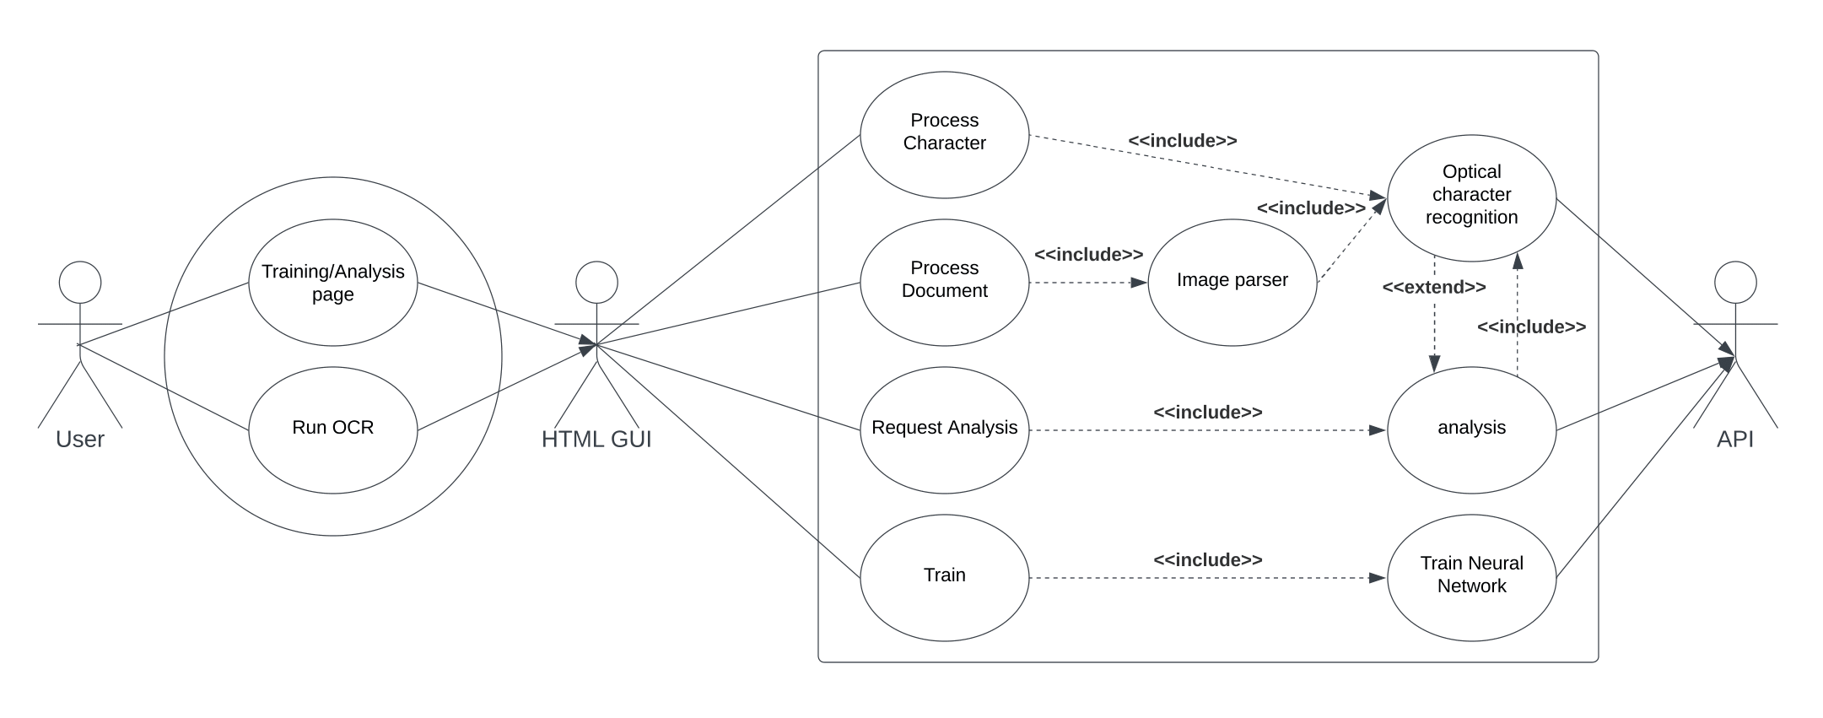
Project plan:

Resources:
- Microsoft Visual studio 2019 / Visual studio code
- node.js
- Web browser
- Downloads of test data from archive.org

Time allocation:

Section | Task | Time required (hours) | Due Date
Analysis | Create and refine idea | 2 | 14/10/22
Analysis | Write description of project | 1 | 14/10/22
Analysis | Define scope, boundaries and constraints | 1 | 14/10/22
Analysis | End user requirement specification | 1 | 14/10/22
Analysis | Functional requirement specification | 1 | 14/10/22
Analysis | Create UML use case diagram | 1 | 14/10/22
Analysis | Conduct Feasibility and User studies | 2 | 14/10/22
Analysis | Project planning | 1 | 14/10/22
Design | Structure diagram for API | 1 | 1/11/22
Design | Define inputs, outputs and data types | 1 | 1/11/22
Design | Pseudocode for neural network | 3 | 1/11/22
Design | Pseudocode for image parser | 2 | 1/11/22
Design | Pseudocode for API | 2 | 1/11/22
Design | Pseudocode for web-server | 2 | 1/11/22
Design | Html interface wireframe | 1 | 1/11/22
Design | Design of server side processes | 2 | 1/11/22
Design | Html interface structure diagram | 1 | 1/11/22
Implementation | Neural network | 4 | 3/6/23
Implementation | Image parser | 5 | 3/6/23
Implementation | API | 2 | 3/6/23
Implementation | Web server | 2 | 3/6/23
Implementation | HTML pages | 1 | 3/6/23
Implementation | CSS styles | 2 | 3/6/23
Implementation | Server-side processes | 1 | 3/6/23
Implementation | Ongoing testing | (time included in other tasks) | 3/6/23
Implementation | Description of research | 1 | 6/3/23
Testing | Create Test plan | 2 | 20/3/23
Testing | Create personas and test cases | 2 | 20/3/23
Testing | Conduct final testing | 2 | 20/3/23
Testing | Document test evidence | 1 | 20/3/23
Evaluation | Fitness for purpose | 1 | 27/3/23
Evaluation | Robustness | 1 | 27/3/23
Evaluation | Consolidate Research | 1 | 27/3/23

TEACHER QUESTIONS

for the uml use case diagram what is a way of illustrating that analysis is optional when conducting OCR but to conduct analysis you must have ran or run OCR along with it to get analytic data

I remember hearing that the user survey is optional but im not sure could you tell me so I can do it if needed same with gannt charts

I may rewrite the scope and functional requirements as I am not fully happy with them

